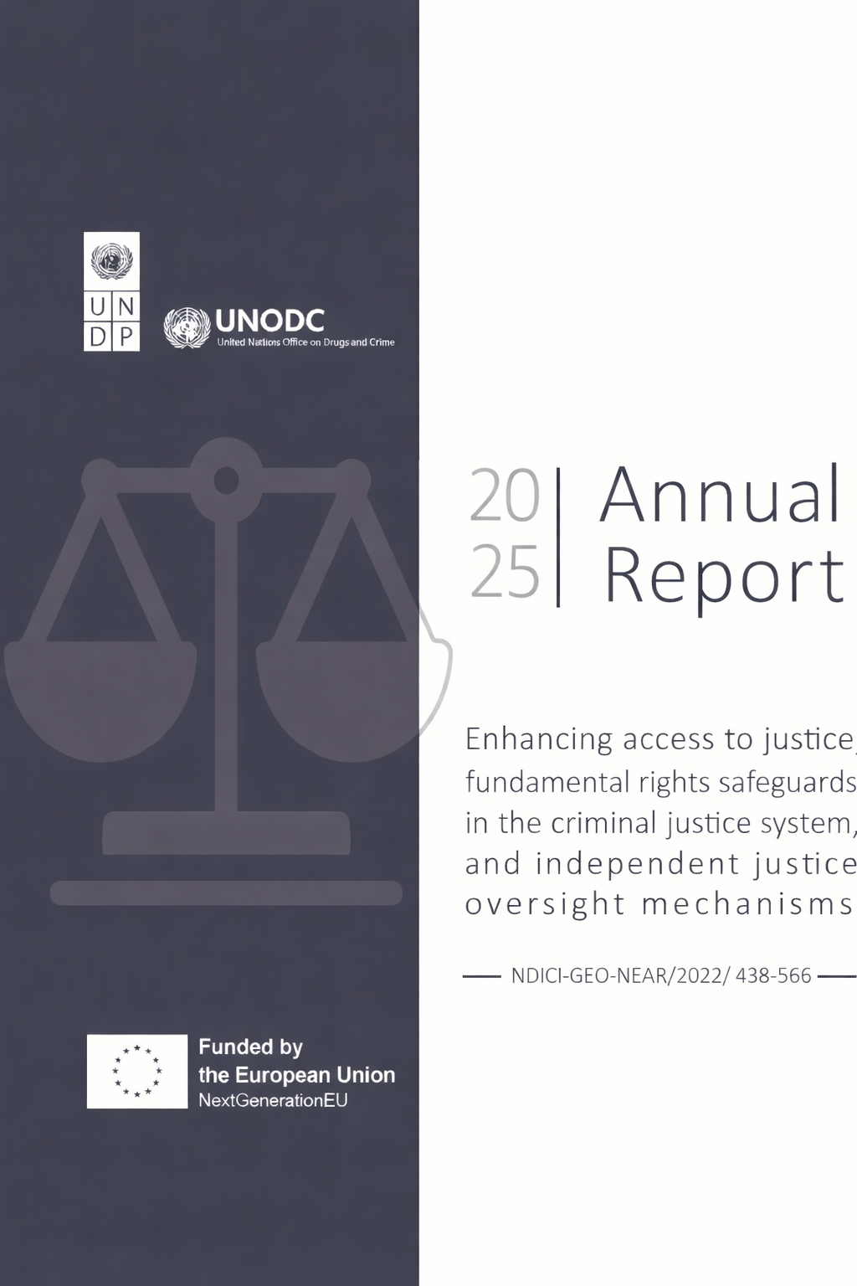

Reporting Period | January 1st, 2025 to December 31st 2025
Donor | The European Union (EU) represented by the European Commission (EC)
Country | Lebanon
Project Title | Enhancing access to justice, fundamental rights safeguards in the criminal justice system, and independent justice oversight mechanisms
Project ID  Award ID  Outputs  Strategic Plan and/or CPD Outcomes | 00106871  00105798  UNDP outputs  - Access to justice to vulnerable groups is enhanced with a focus on the criminal justice chain and mediation  - Effectiveness and independence of justice oversight institutions and mechanisms are strengthened  UNODC outputs  - Prison environment, health conditions and sustainable needs responses are enhanced as per Mandela rules  - Detention conditions, education/social programmes and services for children in conflict with the law are improved, including the operationalization of the Warwar correctional facility for children (boys)  Outcome 2: Strengthened security, stability, justice, and peace
Implementing Partner(s) | UNDP, UNODC
Project Start Date | January 1, 2023
Project End Date | June 30, 2026
Total Budget: | EUR 6 Million / $6,219,600  - UNDP: EUR 3,300,000 / USD 3,420,780  - UNODC:EUR 2,700,000 / USD 2,798,820
Actual Budget (UNDP + UNODC) | - Spent/committed to date: USD $4,175,597.72  - Remaining: USD $2,044,002.51
UNDP Contact Person | Nino Karamaoun  Chief Technical Advisor, Security, Justice & Human Rights  UNDP Lebanon  E-mail: nino.karamaoun@undp.org

Table of Contents

Executive Summary ______________________________________________________________________ 4
I. Introduction ___________________________________________________________________________ 5
II. Considerations on the Operational Environment______________________________________________ 5

III. Progress review________________________________________________________________________ 7
Output 1 Access to justice to vulnerable groups is enhanced with a focus on the criminal justice chain and mediation ……………………………………………………………………………………………………………………………………….……………… 7
Output 2 Effectiveness and independence of justice oversight institutions and mechanisms are strengthened .…………………………………………………………………………………………………………………………………………………..……………….. 14
Output 3 Prison environment, health conditions and sustainable needs responses are enhanced as per Mandela Rules ……………………………………………………………………………………….…………………………………………….………………….….20
Output 4 Detention conditions, education/social programmes and services for children in conflict with the law are improved, including the operationalization of the Warwar correctional facility for children (boys), with particular attention to the specific needs of girls.…………………………………………………………….…………..………….……25

IV. Final Considerations on risk & way forward ________________________________________________ 30

V. Results Framework____________________________________________________________________ 32

Annex A: Financial report ________________________________________________________________ 35

Executive summary

- The present narrative report covers the second year of implementation, the period ranging from January 1st, 2025, to December 31st, 2025. It is to be read in conjunction with the financial report covering the same period presented in annex.

- Lebanon’s trajectory shifted dramatically from near-total collapse and a deepening humanitarian and socio-economic crisis to a fragile opening following the cessation of hostilities with Israel on 27 November 2024. The end of more than 13 months of escalating violence—which resulted in 3,961 deaths, 16,520 injuries, and widespread infrastructure damage—was soon followed by presidential elections in January 2025, breaking a political deadlock after 12 failed attempts. A reformist government subsequently took office, followed by the successful delivery of municipal elections, marking a critical turning point in the country’s recent history.

- As the new government assumed responsibility it faced the urgent task of responding to mass displacement, extensive destruction, persistent political turmoil, and economic instability. Incidents of inter-communal and inter-sectarian tension continue to surface across the country, heightened by polarizing political rhetoric following the ceasefire. Moreover, developments in Syria added further complexity to an already fragile regional environment, particularly in the Northern governorate.

- Against this backdrop, UNDP and UNODC intensified their efforts to address both the consequences of the war and long-standing structural challenges. Through sustained engagement with security and justice institutions, the two agencies played a pivotal role in supporting national stability and strengthening oversight and operational standards—contributions that remain tangible and critical in the post-recovery period, with the aim of reducing tensions, bolstering community resilience, and enhancing public safety.

- During the reference period, several notable achievements advanced key activities toward completion and strategically positioned priority reform initiatives to deliver tangible and sustainable results. In particular, UNODC successfully supported the establishment of a dedicated rehabilitation centre for boys in conflict with the law outside prison settings, alongside updates to the BASEM prison information management system to align it with the operational needs of the Warwar Rehabilitation Centre.

- Sustained engagement by the UNDP team advanced the National Human Rights Commission (NHRC) toward GANHRI accreditation, with its long-pending bylaws signed by the Minister of Justice and submitted to the Council of Ministers for final approval. UNDP also completed a comprehensive cost–benefit analysis assessing the value of investing in legal aid, drawing on evidence from UNDP-supported legal aid models and reinforcing the case for its institutionalization as a core component of Lebanon’s justice and social protection reforms.

- Renovation works at four ISF stations were finalized in line with community policing standards and Article 47 guarantees. Standard operating procedures for managing Article 47 safeguards at these pilot stations are currently undergoing a final round of refinement through coordination between the Public Prosecution Office and the Ministry of Interior, taking into account Lebanon’s complex legal and security context and operational constraints.

- Introduction

- As per the contribution agreement signed on 22 December 2023 and associated annexes, the United Nations Development Programme (UNDP) and United Nations Office on Drugs and Crime (UNODC) in Lebanon are implementing the action “Enhancing access to justice, fundamental rights safeguards in the criminal justice system, and independent justice oversight mechanisms” (the action). The implementation period of the agreement is 36 months starting January 1st 2023, with an additional 6-month extension.

- The action is articulated around four outputs, with UNDP leading on the implementation of outputs 1 and 2; and UNODC on outputs 3 and 4:

- Output 1: Access to justice to vulnerable groups is enhanced with a focus on the criminal justice chain and mediation (UNDP)

- Output 2: Effectiveness and independence of justice oversight institutions and mechanisms are strengthened (UNDP)

- Output 3: Prison environment, health conditions and sustainable needs responses are enhanced as per Mandela rules (UNODC)

- Output 4: Detention conditions, education/social programmes and services for children in conflict with the law are improved, including the operationalization of the Warwar correctional facility for children (boys) (UNODC)

- The present narrative report covers the second year of implementation, the period ranging from January 1st 2025 to December 31st 2025. It is to be read in conjunction with the financial report covering the same period presented in annex.

- Considerations on the Operational Environment

- On 27 November 2024, a Cessation of Hostilities (CoH) agreement signed by Israel and Lebanon entered into force, putting a halt to over 13 months of escalating hostilities. By the time the agreement was announced, the violence had resulted in over 3,961 deaths (including 736 women and 248 children) and over 16,520 injured (MoPH-12/2024), as well as extensive damage and loss to civilian and critical infrastructure and utilities. Fires ravaged agricultural lands and disrupted agricultural activities, causing widespread destruction to lands and crops, particularly in South Lebanon. In total, close to 2200 hectare of land had been burned, and agricultural activities had been disrupted across 130,000 hectares, approximately a quarter of Lebanon’s arable land (National Council for Scientific Research - CNRS-12/2024).

- Although a ceasefire agreement was brokered, the security situation throughout 2025 remained highly volatile. Repeated ceasefire violations were reported, including airstrikes, artillery fire, drone strikes, and shelling across southern Lebanon, the Bekaa Valley, and areas near Beirut’s southern suburbs. As a result, insecurity persisted beyond the formal cessation of hostilities. Civilians continued to be killed and injured, infrastructure was damaged, and many displaced families were unable to return safely to their homes. The ongoing threat of renewed escalation also created an environment of chronic fear, stress, and uncertainty among the population.

- These psychological and security pressures were particularly acute in places of detention. Prisoners experienced heightened anxiety due to concerns for the safety of their families living in affected areas and limited access to communication during periods of heightened tension. Overcrowded prisons, limited emergency preparedness, and weak institutional capacity also increased the risk of vulnerability in the event of escalation.

- Lebanon’s newly formed government is confronting a deteriorating security environment, marked by growing public concern over physical safety and community security, now widely perceived as a major risk to national stability. Of particular concern is the reported re-emergence of informal security arrangements across the country. Often backed by political parties, religious groups, or neighborhood networks, these arrangements reflect mounting pressure on formal security agencies that are grappling with severe resource and operational constraints, as well as a widening trust deficit. Such informal structures raise significant concerns related to human rights, gender inequality, discriminatory and arbitrary practices, accountability, and the politicization of security functions.

- In response, the Ministry of Interior and Municipalities (MoIM) has undertaken a series of measures to curb criminal activity and reinforce security nationwide, including reshuffles and new appointments within key security institutions. The newly appointed Minister of Interior—formerly head of the ISF Academy and closely familiar with UNDP’s work on community security and access to justice—has expressed strong support for the project’s objectives and ongoing interventions.

- Progress Review

Output 1
Access to justice to vulnerable groups is enhanced with a focus on the criminal justice chain and mediation

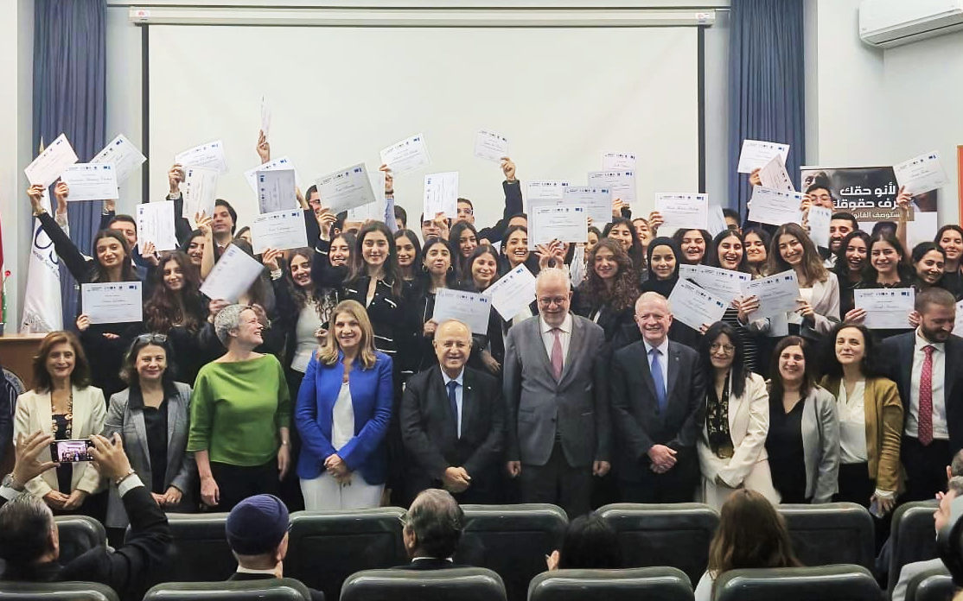

Main achievements
- Graduation of 90 law students, marking the successful conclusion of EU support to the USJ Legal Clinic.
- Operationalization of the BBA Prosecution Office, including IT hardware and software systems, to safeguard the rights of victims of the 4 August Beirut blast.
- A total of 535 inmates including 69 women received free legal assistance at the legal aid helpdesks in Roumieh and Baabda prisons.
- A total of 1362 individuals including 731 women benefitted from free legal aid services provided by the Université Saint-Joseph helpdesk in Beirut.
- A total of 224 individuals—both Lebanese and foreigners—received free legal assistance during preliminary investigations (article 47) by Beirut and Tripoli Bar Associations.
- Four ISF stations in Beirut that are fully equipped in line with Article 47 guarantees and connected to the ISF Directorate are pending SOP and MOT approvals.

Activity 1.1: Development and piloting of a legal aid helpdesk model for prisons through the Access to justice working group (A2JWG)

- As the prison legal aid helpdesks entered their second year of operation, four deliverables were successfully completed, alongside a growing number of new requests and inquiries as awareness of the service increased among prisoners. This expansion took place within a broader reform-oriented context following the appointment of a new government, particularly the Ministry of Justice’s submission of a draft law on judicial independence, which—after several deliberations—was approved by the State as a landmark step along Lebanon’s long and challenging path toward accountability and good governance. These developments contributed to a more enabling environment for advancing justice sector reform, as official negotiations commenced on the release of hundreds of prisoners who have overstayed their sentences or remain in pre-trial detention.

- Construction works for the prison legal aid desks in Baabda and Roumieh were completed, and the SOPs governing their operationalization were approved by the ISF following several months of negotiations addressing inmate-related security risks and the required clearances from multiple MoIM officials. The approved SOPs regulate the prison entry procedures for the prison helpdesk team and the scope of services provided. During the reporting period, a total of 501 inmates—including 69 women—received free legal aid services, encompassing legal counselling, assistance, and representation, with 265 inmates benefiting from more than one service. One awareness-raising session was conducted at the Roumieh Prison helpdesk, reaching 34 male inmates and addressing a frequently raised topic, namely merger procedures and the Penalty Reduction Law. However, due to security constraints and the absence of a secure space suitable for safely accommodating multiple inmates, UNDP conducted a post-implementation needs assessment and determined that discontinuing awareness-raising sessions and reallocating efforts toward increasing targets for other services—particularly legal assistance—would be more efficient and impactful.

- Over the past year, the helpdesk team received a growing number of new inquiries submitted on behalf of inmates, reflecting the expansion of services to address a broader and more diverse range of legal and procedural issues, including:
  - Requests for transfer to a detention facility closer to the inmate’s place of residence
  - Requests related to access to medical services
  - Requests for assistance with transferring case files to the competent court
  - Inquiries on procedures for expediting cases or transferring them from one court to another
  - Requests for support related to release, including in cases where inmates were already represented by private counsel
  - Follow-up requests regarding sentence reductions and the status of the sentence reduction committee
  - Inquiries regarding the maximum legal duration of pre-trial detention
  - Requests for release on bail
  - Questions regarding the possibility of family-provided guarantees for release
  - Inquiries concerning inmates’ rights in cases of extended pre-trial detention

- During the reporting period, the prison helpdesk team identified several emerging challenges as team members became more familiar with the prison dynamics and gained increased trust and recognition among inmates due to their sustained engagement and service delivery. The identified challenges include:

Resource and staffing shortages
- Acute lack of stationery, printing materials, and basic office supplies in Roumieh and Baabda prisons.
- Chronic understaffing delaying detainee coordination, court appearances, and processing of legal requests.

Prolonged and unlawful detention practices
- Extended pre-trial detention without indictment, particularly in Baabda, in some cases exceeding likely sentence durations.
- Routine denial of release requests in specific case categories, limiting access to sentence reduction mechanisms.

Judicial and procedural delays
- Delayed transfer of files between courts and infrequent updates of judicial bulletins, resulting in outdated or incomplete legal status information.
- Failure to transfer detainees to distant courts, leading to repeated hearing postponements and fair-trial violations.

Administrative inefficiencies and record errors
- Inaccurate recording of case and prosecution file numbers, requiring repeated follow-up and manual file searches.
- In absentia arrest reports not transmitted to case files, leaving judges uninformed and detainees in prolonged detention.

File accessibility and document mismanagement
- Inaccessibility of files related to old in absentia warrants, due to missing or disorganized archives.
- Loss or delayed transmission of judicial decisions and detention orders between courts and prisons.

Financial barriers within judicial procedures
- Excessively high bail amounts and informal financial demands by court clerks for routine administrative actions.
- Non-statutory court fees blocking case progression and access to justice for detainees unable to pay.

CASE SPOTLIGHT:  Prompting the issuance of an indictment | In early 2025, the prison helpdesk in Roumieh uncovered the cases of two detainees who had been held for months in pretrial detention, with their files stalled in the accusation chamber under Judge Francis. Despite the time elapsed, no accusation ruling had been issued—effectively placing them in a state of legal limbo and arbitrary detention.  Actions Taken by the Prison Helpdesk:  The helpdesk persistently followed up on their cases, repeatedly speaking with the judge to urge progress. Recognizing the need for a more efficient and documented procedure, the team developed a new strategy: a written request template addressed to the accusation chamber, formally urging the issuance of the accusation ruling while simultaneously requesting the detainees' release.  This proactive approach proved effective. The judge welcomed the clarity and formality of the written request, reportedly appreciating the systemization it introduced to his workflow. Within one week, he issued the accusation ruling and, at the same time, approved the release of both detainees on bail set at 50 million Lebanese pounds each.  This success not only restored the liberty of two individuals unjustly held, but also demonstrated the power of structured, strategic legal advocacy. More importantly, it opened the door for potential procedural improvements within the judiciary, highlighting how a simple written tool can reduce arbitrary delays and promote fairer, faster access to justice.

CASE SPOTLIGHT:  Rectification of an Unlawful Detention | In October, the Roumieh prison helpdesk received the case of a detainee whose prolonged detention raised serious legal concerns. The individual had been held in prison well beyond the legally permissible period, with the only pending step being the delivery of the official sentencing form.  Actions Taken by the Prison Helpdesk:  Upon reviewing the file, the helpdesk discovered that, although the case had been transferred to the Jounieh Court, no sentencing documents were present. Further investigation revealed that the detainee had been sentenced in July; however, the official sentencing form had not been transmitted to the prison, resulting in continued unlawful detention.  This finding prompted a comprehensive investigation. The helpdesk team pursued all possible avenues, including:  - Jounieh Court  - Hobeish Police Station  - Liban Post (courier service)  - Office of the Director of Prisons  Each institution initially denied possession of the file. When a request for a replacement sentencing form was made, a further obstacle was discovered: the detainee’s complete file was missing.  Over the course of one week, the helpdesk conducted an exhaustive search, reviewing documents, examining storage areas, and cross-checking records at both the General Prosecutor’s Office and the Jounieh Court. The investigation ultimately revealed that the file had been inadvertently placed inside another detainee’s folder. Both folders had been sent together in a single envelope, causing misplacement.  Once identified, the sentencing form was immediately issued and delivered to the prison. After nearly four months of unjust detention, the detainee’s legal status was rectified, and their rights were fully restored.  This case highlights the critical importance of sustained legal oversight within the justice system. Persistent engagement, including regular visits, direct communication with court staff, and thorough review of administrative procedures, is essential to safeguard the rights of individuals who might otherwise be overlooked. It underscores how diligence, coordination, and legal advocacy can directly correct systemic errors and restore justice and dignity.

Activity 1.2: Development and piloting of an additional model legal aid helpdesk model to safeguard rights of vulnerable groups

- During the reference period, the University helpdesk/legal clinic model based at the Saint Joseph University USJ) in the Beirut/Mount Lebanon area provided 1,362 individuals (including 732 women) with free legal aid services. These services were catered by volunteer third- and fourth-year law students, under the supervision of USJ Law professors/lawyers, providing them with practical experience and sensitizing them to the importance of free legal aid, a concept not yet widely established among legal professionals in Lebanon.
Service repartition during the reference period is as follows:

Services | Females | Males | Total
Legal Awareness | 654 | 592 | 1246
Legal Counselling | 25 | 15 | 40
Legal Assistance | 33 | 12 | 45
Legal Representation | 11 | 9 | 20
Legal Mediation | 9 | 2 | 11

- The majority of cases addressed by the desk pertained to (54%) personal cases including DNA testing, family disputes, guardianship, protection of minors, inheritance law, and (11.32%) criminal matters (criminal record issuance), and (11.32%) administrative cases, including residency status and the rights of domestic workers. Over 54% of the cases were initiated through referral and awareness raising sessions during which individuals approached the legal aid helpdesk team for additional inquiries and guidance. A total of 29 calls were received on the hotline, which was activated to promote accessibility and confidentiality.

CASE SPOTLIGHT:  Migrant Worker Repatriation | A Filipina woman who had entered Lebanon to work under the kafala system left her place of employment and subsequently began working at a local restaurant. She was later apprehended by the General Security Office for violations related to the terms of the kafala system and was placed in custody pending legal and administrative procedures.  Actions Taken by the Legal Clinic:  Upon receiving a request for assistance from a friend of the detainee, the Legal Aid Clinic intervened by identifying the woman’s place of detention and reviewing her legal and administrative file. The legal aid team subsequently facilitated contact with the sponsor to explore options for resolving the case. Through sustained follow-up, the Clinic secured the sponsor’s agreement to cover the costs of the return flight and sign the necessary waiver, enabling the detainee’s safe and lawful return to her home country.

- After several postponements due to the prevailing security situation in the region and in Lebanon, the long-awaited graduation and certificate award ceremony was held on 5 December 2025, marking the graduation of 90 third- and fourth-year law students enrolled in the Legal Clinic. Throughout their participation, these students contributed to the provision of free legal aid services through USJ’s Legal Clinic, ensured daily in-person rotations at the clinic, and operated the clinic’s hotline from 10:00 a.m. to 5:00 p.m., five days a week, under the supervision of USJ law professors and practicing lawyers. The event also recognized the dedication of the Legal Clinic team and acknowledged the partners who have supported the initiative since 2023.

- The ceremony was attended by Professor Salim Daccache, President of the University, and Professor Marie-Claude Najm, Dean of the Faculty of Law and former Minister of Justice. High-level participants included Mr. Adel Nassar, Minister of Justice; Ms. Sandra De Waele, Ambassador of the European Union to Lebanon; Ms. Blerta Aliko, UNDP Resident Representative in Lebanon; General Raymond Khattar, Director General of the Lebanese Civil Defense and member of the A2JWG; a representative of the Tripoli Bar Association; and Ms. Elisabeth Sioufi, representing the Beirut Bar Association.

- The event marked the conclusion of the European Union’s support to the USJ Legal Clinic after two years of effective delivery of comprehensive legal aid services targeting vulnerable populations. It also highlighted tangible progress toward the establishment of an institutionalized national framework for the provision of free and quality legal aid in Lebanon, demonstrating concrete advances in the operationalization of this vision. Furthermore, the ceremony underscored the central role of the Access to Justice Working Group in shaping and advancing a national legal aid strategy through diversified service delivery models. As an integral component of this framework, the USJ Legal Clinic serves as a replicable model for the provision of free, quality legal aid, while fostering a culture of social responsibility and rights-based practice among future legal professionals.

Activity 1.3: Production of a study on legal aid service delivery models and elements for an improved access to justice / Legal Aid system strategy to be advocated with the authorities
- As part of its efforts to advocate for and support the establishment of a national state-owned legal aid system, UNDP supported the drafting of a comprehensive legal aid study with a cost–benefit analysis (CBA) examining the value of investing in legal aid and building the case for its institutionalization as a cornerstone of Lebanon’s justice and social protection reforms. The assessment pursued three complementary objectives:

- first, to review existing UNDP-supported legal aid helpdesks in order to identify strengths, gaps, and opportunities to improve service delivery and sustainability within a future national system;
- second, to assess the economic and social returns of investing in legal aid;
- and third, to provide recommendations towards the progressive establishment of a national legal aid framework.

- The study, based on evidence generated from UNDP-supported legal aid models, confirms that legal aid delivers strong economic, social, and institutional returns. Moreover, the study exhibits how the provision of legal awareness, advice, assistance, representation, and mediation, legal aid reduces pressure on courts and detention facilities, enables early dispute resolution, and strengthens due process and procedural safeguards. At the individual level, it has helped prevent illegal evictions, secure wages and civil documentation, and support women in accessing alimony, custody, and protection orders, thereby contributing to legal and economic empowerment. In detention settings, legal aid has reduced arbitrary and prolonged detention, while at the community level it has contributed to de-escalation of tensions, strengthened social cohesion, and supported conflict prevention. Overall, the CBA estimates that legal aid generates significant economic and social value for the state, delivering approximately $2.33 in benefits for every $1 invested, including reduced court congestion, lower detention costs, early dispute resolution, socio-economic empowerment, and improved well-being.

- The findings further highlighted that justice needs in Lebanon are complex, interconnected, and largely non-criminal, underscoring the need for holistic and people-centred responses. Pilot models implemented through bar associations, municipalities and NGOs, universities, prisons, and statutory Article 47 committees demonstrated that diverse, flexible, and locally adapted delivery modalities can effectively expand access to justice. Embedding legal aid services within local governance structures, deploying mobile outreach to underserved areas, and engaging community actors and non-lawyers proved critical to improving outreach, trust, and responsiveness. Strengthening the capacity of bar associations and fostering cross-sector partnerships with social and health service providers further enhanced the ability of legal aid to address broader socio-economic vulnerabilities.

- Overall, the legal aid study provided a solid evidence base for scaling legal aid and advancing toward a comprehensive national legal aid system, drawing on international best practices and lessons learned from pilot legal aid desks. The findings reinforce that legal aid is not only a social good, but a strategic investment that supports poverty prevention, social protection, and judicial efficiency, while advancing national development priorities and UNDP Sustainable Development Goals. They highlight the central role of the Ministry of Justice and the A2JWG in leading an inclusive, evidence-informed process to develop a unified legal aid policy, legal framework, and implementation plan.

- UNDP is coordinating the launch of the study’s results planned for Q2 2026, anchored in five core messages: (i) Lebanon now has a solid evidence base demonstrating unmet justice needs and the economic and social returns of investing in legal aid, enabling a shift toward a comprehensive national system; (ii) addressing people’s justice needs requires a mix of delivery models that combine legal representation with accessible information, counselling, and referral services; (iii) legal aid is a critical enabler of social protection and justice sector reform, preventing deeper poverty and generating data to inform people-centred policy change; (iv) effective legal aid depends on coordinated, multi-stakeholder engagement through a whole-of-government and whole-of-society approach; and (v) the A2JWG is well positioned to lead the development of a sustainable, rights-based national legal aid system by guiding governance, financing, delivery models, and oversight.

Activity 1.5: Support Beirut and Tripoli bar associations to ensure provision of legal assistance during preliminary investigation as per amended art. 47 CPC

- Throughout the year, referral systems and dedicated hotlines remained operational, providing prompt and effective service delivery in accordance with article 47 timelines. Supporting these efforts were sensitization initiatives and training workshops catering to lawyers and security officials alike with the objective of fostering a more cooperative security apparatus, that is showing more acceptance and adherence to Article 47 guarantees.

- At the invitation of the President of the Beirut Bar Association, the Beirut Bar Association in cooperation with UNDP, organized a National Conference on the Proper Application of Article 47 of the Code of Criminal Procedure. The conference was attended by the Minister of Justice, the Chair of the Parliamentary Administration and Justice Committee, the Public Prosecutor at the Court of Cassation, the President of the North Lebanon Bar Association, representatives from the Ministry of Interior and Municipalities, Ministry of Defense, security agencies, and UNDP.

- In his closing remarks, the BBA president stressed the need for strict implementation of the amended Article 47. The conference concluded with five key recommendations:

- Issuing binding circulars to all Public Prosecution offices to strictly enforce Article 47, including adherence to the four-day maximum detention period and the requirement that the questioning of lawyers be conducted exclusively by the Public Prosecution and in the presence of a Bar Association representative.

- Issuing directives by security agencies to ensure the literal application of Article 47, including the immediate right of detainees to make two phone calls, the prevention of any form of coercion, and the facilitation of lawyers’ access to investigation centres.

- Strengthening coordination between concerned ministries, both Bar Associations, and UNDP to initiate the audio-visual recording of all preliminary investigations, in line with the final paragraph of Article 47, and to secure the necessary funding.

- Designating a Public Prosecutor at the Court of Cassation as a liaison between the Bar Association and Public Prosecution offices to address implementation challenges.

- Appointing liaison officers within security agencies to coordinate with the Bar Association through the monitoring committee and support the effective application of Article 47.

- As security and justice institutions increasingly demonstrate commitment to the implementation of the Article 47 guarantees, the BBA committee in 2025 provided legal assistance to 148 individuals, both Lebanese and non-Lebanese, during preliminary investigations. In parallel, the TBA Article 47 committee assisted 80 individuals in similar proceedings, with 47 cases subsequently benefiting from legal representation before the competent courts following referral.
Most prominent cases handled by both committees were:
- Drug abuse  - Domestic violence  - Defamation (libel & slander)  - Tax evasion | - Theft  - Fraud  - Assault  - Forgery and discharge of a firearm
Activity 1.6: Sensitization and capacity building activities for justice and security stakeholders on art. 47 guarantees

- In 2025, both Bar Associations continued to strengthen professional capacities and empower stakeholders and local communities with legal knowledge on the importance of safeguarding suspects’ rights during preliminary investigations. Through targeted sensitization, training, and awareness-raising activities, a significant number of security personnel, legal professionals and university students were reached on the rights enshrined in the amended provisions of Article 47 guarantees.

- BBA Article 47 Committee: Although the BBA engaged a wide range of individuals through awareness and sensitization activities, reluctance among detainees to invoke the safeguards provided under Article 47 persisted, largely due to concerns about potential legal fees. In addition, ISF stations that have not yet been sensitized continue to under-refer detainees to the Article 47 committee. Despite the issuance of a relevant directive, greater proactivity by ISF officers remains necessary to ensure detainees are adequately informed of their rights during preliminary investigations.

- In 2025, the BBA Article 47 committee organized ten awareness-raising sessions, reaching a total of 441 beneficiaries, including 8 ISF officers, 336 lawyers, 30 LAF officers, 46 State Security agents, and 21 General Security officers. In parallel, the BBA in coordination with the MoIM continued to distribute previously developed sensitization materials across investigation centres. More than 200 investigation rooms in various ISF stations were visited, where educational visuals were installed outlining detainees’ rights during preliminary investigations. In addition, the Head of the BBA Article 47 committee made several appearances on prime-time television, further promoting awareness of Article 47 guarantees and expanding outreach to a wider audience.

- TBA Article 47 Committee: During the reporting period the TBA Article 47 committee organized four trainings and eight awareness-raising sessions, reaching a total of 430 beneficiaries, including 101 university students, 194 civil society activists, and 135 lawyers. These sessions featured interactive discussions and focused on strengthening the application of Article 47 of the Lebanese Code of Criminal Procedure, enhancing the capacities of lawyers, students, and activists, and raising awareness on detainees’ procedural safeguards. Participants were introduced to essential tools for navigating legal complexities, with emphasis placed on the importance of legal representation and the consequences of non-compliance.

Main topics that were discussed during these sessions were as follows:

- Implementation mechanisms of Article 47, including ethical considerations and practical challenges related to its application
- Procedural safeguards under Article 47, associated implementation challenges, and the role of the Juvenile Delegate in ensuring compliance
- Rights upon arrest and procedural protections guaranteed under Article 47
- Practical barriers to the implementation of Article 47 and mechanisms to support vulnerable groups during detention
- Detainees’ rights, including access to legal counsel during arrest and detention
- Mechanisms for accessing legal representation and ensuring effective legal assistance from the moment of arrest

- Complementing these sessions, the TBA Article 47 committee maintained close coordination with the ISF – North Region Command, which supported the committee’s informal sensitization of ISF stations through the distribution of posters, banners, and stickers highlighting Article 47 guarantees. In addition, the TBA committee developed a coordinated plan with Lebanese Army Intelligence aimed at promoting the application of Article 47 during LAF interrogations. This represents a precedent-setting step, particularly given that Army Intelligence has traditionally not permitted the presence of lawyers during interrogations.

Law 191/2020 | Amid the 2020 “uprising”, Law 191 was enacted to amend the Code of Criminal Procedure (CPC, primarily article 47), with the objective of reinforcing fundamental due process guarantees. Dubbed the “Law to strengthen basic guarantees and activate human rights”, the text sought to strengthen human rights oversight, by amongst others guaranteeing recourse to an attorney during preliminary investigations, and access to sound and image recordings of interrogations.

Activity 1.7: Support General Prosecutor’s office on implementation of article 47 guarantees
Activity 1.8: Development of pilot police station(s) for full implementation of art. 47 guarantees

- The operationalization of Article 47 is in its final stages, with the General Prosecutor’s Office and the ISF resolving the remaining technical and procedural details.
  - Developing Standard Operating Procedures: SOPs were finalized and approved by the Public Prosecution Office, after which continued dialogue with security and justice stakeholders prompted minor refinements to better reflect operational realities. To further support effective implementation, workshops and high-level exchanges between the Prosecutor General and ISF command are planned for Q2 2026, focusing on the application of Article 47 and addressing practical challenges encountered in applying the SOPs.

  - Piloting audio/video recording: Following the necessary approvals from ISF leadership and the General Prosecutor’s Office, six ISF stations have been equipped with audio-video recording systems. Their full use will depend on the completion of the related SOPs; nevertheless, the installations establish the technical preconditions for improved procedural safeguards and enhanced transparency in the application of Article 47.

- Four ISF stations in Beirut (Raouche, Ramleh al-Bayda, Achrafieh, and Ras Beirut) are now fully equipped in line with Article 47 guarantees and connected to the ISF Directorate via fiber optic installations, including model investigation rooms with dedicated control rooms refurbished in accordance with international standards. Relevant staff have received training on the use of the recording software and investigation rooms to support effective implementation.

- Data Security Measures: A comprehensive assessment conducted in 2024 identified a critical need to equip ISF stations, the Public Prosecution Office, and the offices of Investigative and Trial Judges with the technological infrastructure required to securely store, access, and review recorded interrogations. Informed by an analysis of the judicial workflow, the assessment highlighted the importance of ensuring access to recordings across all stages of the legal process, from preliminary investigation through trial.

- Based on the assessment’s findings, a dedicated software system was developed to support the implementation of Article 47, with a focus on sustainability, flexibility, and scalability for potential nationwide rollout. The system is now completed and deployed; however, its operational use remains pending the finalization of the related SOPs.

Completion and full deployment of the software for operational use is expected in Q3 2026.

The system integrates the following key features:
- Redundant server infrastructure: Two servers located within the ISF Directorate store recordings redundantly, minimizing the risk of data loss.
- Enhanced monitoring: Cameras are strategically placed within and outside interrogation rooms to ensure oversight of the recording process and deter tampering.
- Robust user authentication: Recordings are linked to individual interrogators through unique credentials, ensuring accountability and traceability.
- Secure data access and sharing: The system enables controlled access to recordings by the ISF Directorate and the Public Prosecution Office, facilitating oversight and coordination, subject to final intranet connectivity approvals.

Final intranet connectivity remains pending approval from the Ministry of Telecommunications and Ogero (Lebanon’s state-owned telecommunications operator) to complete system integration.

Activity 1.9: Support to the prosecution office of the Beirut Bar Association (BBA) to ensure safeguarding of rights of the victims of the August 4th Beirut blast

- During the reference period, an agreement was reached with the Prosecution Office of the BBA on the scope of UNDP support. This support focuses on staffing, office equipping, and the development and installation of a dedicated software solution, which has now been finalized, to enable the indexing, storage, and secure retrieval of the thousands of pages of case-related documentation. The system supports volunteer lawyers representing victims through a dedicated office established and fully equipped at the “Maison de l’Avocat.”

- Support to the Prosecution Office at the Beirut Bar Association is structured around two complementary tracks:

Staffing Support
UNDP contracted three personnel to support the Prosecution Bureau at the BBA, including two junior lawyers (one Criminal Litigation Attorney and one Civil Litigation Attorney) and one paralegal. These personnel are actively deployed and jointly manage the Bureau’s extensive caseload. The lawyers are responsible for drafting criminal complaints and civil claims, representing victims and their families before competent courts, and coordinating legal strategies, while the paralegal provides essential administrative and case-management support.
This staffing support has strengthened the BBA’s capacity to expedite case processing and pursue justice, accountability, and reparations for victims and their families. Contracts have been extended until March 2026, ensuring continuity of support.

Office Equipping, IT Hardware, and Software Development

A dedicated office located on the second floor of the “Maison de l’Avocat” has been fully furnished and is operational. The office has been equipped with desks and chairs, a meeting table for 12 persons, filing cabinets, and roller blinds, all of which have been delivered and installed.

In parallel, IT hardware has been fully procured and installed, including a laptop for each staff member, a multifunction printer/scanner/copier, an interactive screen, and a Wi-Fi access point connected to a local server. This infrastructure is currently in use by the Prosecution Bureau team.

To support case management and documentation, two interlinked software systems have been developed and are operational, with data entry ongoing:
- A secure internal document and records management system, integrated within a local network and centralized drive, enabling structured archiving, metadata tagging, indexing, and advanced search functionality. Access controls are in place to ensure that only authorized users can view or modify sensitive case files, thereby preserving confidentiality.
- A complementary public-facing online interface, securely connected to the internal system, allowing the public to submit requests for case-related information and upload new case documents. Office assistants are currently using this interface to retrieve, review, and classify documents, with strict access controls ensuring that only non-confidential materials are handled.

Overall, the office infrastructure, IT hardware, and software systems are fully established and operational, with ongoing data entry and migration supporting the progressive consolidation of the Prosecution Bureau’s case database.

Activity 1.10: Support development of judicial and non-judicial mediation legislation implementation decrees, operationalization of relevant legislation, streamlining of mediation/ADR services through legal aid helpdesks, and capacity building/awareness sessions for legal professionals

- Promoting and expanding the use of Alternative Dispute Resolution (ADR) mechanisms has proven to be a critical step in enhancing access to justice while alleviating court congestion and reducing case backlogs. In this context, beneficiaries accessing UNDP-supported legal aid helpdesks continued to be guided toward mediation as an effective and timely means of resolving disputes.

- During the reporting period, the North Governorate legal aid helpdesk handled 14 mediation cases spanning personal status, civil, and labor disputes. The majority of these cases involved marital disputes, alongside cases related to unfair dismissal and rental disagreements. In parallel, the Baalbek and Saida legal aid helpdesks each managed one mediation case, both of which also concerned marital disputes.

- The legal aid clinic at USJ managed 11 mediation cases during the same period. One case was unsuccessful due to the refusal of the other party to participate in the mediation process. Overall, the disputes were predominantly family-related, with nine family disputes recorded alongside one neighborhood dispute, underscoring the largely familial nature of inheritance-related conflicts addressed through mediation.

- At the policy level, and under the auspices of the newly appointed Minister of Justice, a draft law is currently under review by the Parliamentary Administration and Justice Committee. The proposed legislation seeks to streamline the mediation framework by consolidating judicial and non-judicial mediation under a unified legal framework, thereby eliminating the need for separate implementation decrees. It further introduces standardized criteria for certifying Lebanese mediation centers authorized to operate, marking an important step toward institutionalizing mediation practices nationwide.

CASE SPOTLIGHT:  Marital mediation | A Lebanese woman, a mother of six children, approached the Tripoli Legal Aid Helpdesk due to ongoing marital difficulties stemming from poor communication with her husband. As a result of these challenges, she had left the marital home but had not yet decided to pursue formal separation. Her primary concern was maintaining contact with her children, whom she wished to see regularly.  Actions Taken by the Tripoli helpdesk:  The Tripoli Legal Aid Helpdesk provided mediation services and facilitated communication between the beneficiary and her husband. A joint mediation session was convened, during which the husband expressed a willingness to reconcile. While the beneficiary indicated that she was not yet ready to return to the marital home, both parties agreed on a temporary arrangement allowing the beneficiary to visit her children once per week. This agreement was reached by mutual consent and aimed at preserving family ties while allowing space for further dialogue.

Output 2
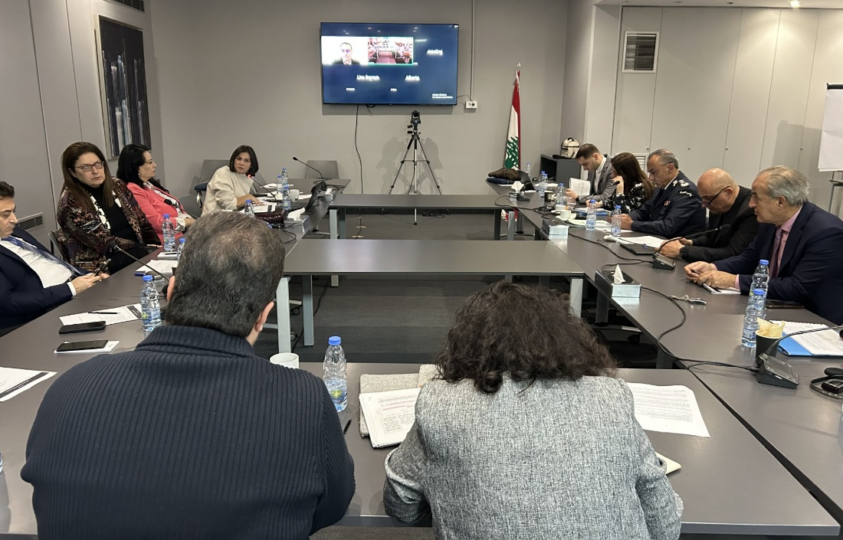
Effectiveness and independence of justice oversight institutions and mechanisms are strengthened

Main achievements
- Support to judicial independence reform through 12 Justice Forum sessions, high-level institutional engagement, and sustained advocacy that directly informed the drafting and adoption of the Law Organizing the Judiciary No. 36/2026.
- Multiple Justice Forum thematic groups implemented in parallel (11 on efficiency and digitalization; 9 on criminal justice and human rights), producing actionable recommendations and reinforcing cross-institutional coordination.
- Generating USD 137,540 in cumulative cost savings and a 194.1 tCO₂ decline in emissions at the Beirut Justice Palace.
- Supported the operationalization of the NHRC, advancing GANHRI accreditation readiness and enabling the release of more than 80 detainees through expedited procedures.
- Laid the foundations for strengthened judicial oversight and accountability by completing the Higher Judicial Council’s database and readying it for implementation, while finalizing a draft of the internal regulations following the enactment of the Law on Organizing the Judiciary.
Activity 2.1: Strategic and technical support, and sensitization/outreach efforts to promote adoption and implementation of independence of the judiciary legislation and justice sector reform
Activity 2.8: Support the Ministry of Justice with the update of its strategic plan and implementation thereof in line with Justice sector (TAEIX) functional review

- The first thematic group on the Independence, Accountability, and Professionalism of the Judiciary concluded in February 2025 after a total of 12 sessions. The recommendations developed through this process were formally presented to key national stakeholders, including the Minister of Justice, the President of Parliament’s Administration and Justice Committee, and the Presidents of the High Judicial Council and the State Council, ensuring early institutional exposure and anchoring ownership of the reform agenda.

- These recommendations directly informed the establishment of an informal commission within the Ministry of Justice, which subsequently contributed to the drafting of the government-approved law on judicial independence. To sustain momentum and support the law’s finalization and adoption, UNDP— in collaboration with the European Union— convened the annual 3RF Justice Working Group, which was strategically leveraged as an advocacy platform around the draft legislation. During the Working Group, the Minister of Justice committed to overseeing the finalization of the draft law, while justice sector stakeholders expressed strong support for its advancement, underscoring the urgency of judicial independence as a long-overdue reform historically constrained by political considerations.

- The Law Organizing the Judiciary No. 36/2026 was adopted on 18 December 2025, marking a tangible step forward in justice sector reform in Lebanon. While the law introduces notable improvements compared to the previous framework, several provisions have been criticized by key stakeholders—particularly civil society actors—who argue that the adopted version provides only limited guarantees for judicial independence and accountability. This feedback highlights the need for continued engagement to support implementation and pursue complementary reforms. In parallel, the roadmap developed under the Independence, Accountability, and Professionalism of the Judiciary thematic group is nearing completion and is expected to be finalized in the coming period, providing a strategic reference for ongoing reform efforts beyond the adoption of the law.

- Building on this progress, the Efficiency, Transparency, Digitalization, and Accessibility of the Justice System thematic group, launched in May 2025, has nearly concluded its work, having held 11 meetings throughout the year focused on operational and service-delivery reforms. The Criminal Justice and Human Rights thematic group was launched on 27 August 2025 and held nine meetings during the reporting period. Technical in nature, the group brought together judges and security personnel, facilitating in-depth discussions and highlighting differing institutional approaches to shared legal and human rights challenges. Its work will continue into 2026, with finalization expected in the first quarter. Preparatory and structuring work for the Juvenile Justice thematic group has also been completed; however, its launch—originally scheduled for late November 2025—was postponed due to the reappointment of the Ministry of Justice focal point, with convening expected once institutional arrangements are finalized.

- Across thematic groups, sessions generated substantive exchanges and constructive debate, culminating in the formulation of both short- and longer-term recommendations tailored to Lebanon’s specific context and grounded in practical feasibility. To enhance transparency, meeting minutes are systematically documented and published online on a dedicated Justice Forum webpage. Previous operational and coordination challenges that had slowed the Forum’s early progress have largely been addressed, allowing thematic groups to operate in parallel and at an accelerated pace. Lessons learned from the first two working groups—particularly regarding logistics, sequencing, and content preparation—have informed the design and conduct of subsequent groups.

- Remaining challenges observed during thematic discussions primarily stemmed from conservative positions held by some justice actors. Debates on criminal law decrees, in particular, revealed interpretative divergences, with security personnel at times adopting more progressive positions than judges, reflecting differing institutional perspectives. In addition, changes in focal points within key justice institutions have resulted in unplanned delays in launching or concluding certain working groups, underscoring the continued sensitivity of reform processes to institutional turnover.

Activity 2.2: Development of judicial inspection referential and application thereof through support to inspection activities in pilot jurisdictions

- The development of an inspection referential (“référentiel d’inspection”) and an inspection methodology based on international best practices is critical to enhancing the periodic monitoring and efficiency of the judicial system. This referential aimed to assess court performance, identify system gaps, and highlight areas for intervention—an aspect previously lacking, as the Judicial Inspection authority primarily focused on its disciplinary mandate. By supporting evaluations of both judges and courts, the initiative sought to promote efficiency, transparency, and accountability within the justice system.

- As previously reported, the draft “projet de référentiel,” was fine-tuned and approved anew by the High Judicial Council. During the reference period, no progress was documented in this regard given that the implementation of this activity was pending the adoption of the law on the independence of the judiciary; the law was supposed to identify the entity that would oversee and assess the performance of tribunals. The consecutive draft laws that were circulating had established an evaluation committee that would either fulfill this task or would attribute this task to the judicial inspection. Additionally, the newly appointed head of judicial inspection insisted on waiting for the law.

- The implementing authority when it comes to judicial evaluation was to be defined by a pending Lebanese law to be passed. Now that the law was passed in December 2025, the implementing entity in charge of inspecting tribunals has been identified, namely, the judicial inspection authority. Hence, efforts will be exerted to implement the activities in the coming quarters.

Activity 2.3: Support the development of a code of deontology or guidelines thereof through an inclusive process

- Support has been initiated to develop a Code de Déontologie for judges, which will include general principles governing the communication of judicial authorities with the media. In line with the newly enacted law, the process will be inclusive and participatory, engaging judges and judicial bodies, lawyers, media representatives, and academics.

- The development and updating of the Code of Déontologie, including provisions regulating relations with the media, directly reflect a recommendation of the Justice Forum, demonstrating its effectiveness as a platform for guiding and informing judicial reform efforts.

Activity 2.4: Support the consolidation and implementation of evaluation of judges’ methodology

- Following the enactment of the Law Organizing the Judiciary, a dedicated evaluation committee has been formally established and mandated to assess judges’ performance. Building on extensive deliberations first with the Higher Judicial Council and subsequently within the Justice Forum, UNDP supported the development of a comprehensive and finalized draft evaluation methodology through an inclusive and consultative process. With the evaluation committee now legally established, efforts will shift toward supporting the implementation phase to operationalize a transparent, merit-based judicial performance system.

Activity 2.5: Support the development of additional monitoring and oversight tools, and of functional and organizational frameworks for justice oversight bodies

- High Judicial Council database: The database was finalized in 2025 and installed at the Higher Judicial Council. Data collection for individual judges is now underway, following the Council’s decision to defer the process until the completion of judicial permutations. With the permutations enacted in November 2025, the Council has initiated data collection, and UNDP will support the subsequent data entry phase.

- In parallel, an agreement was reached to grant the Judicial Inspection access to the Higher Judicial Council’s database to prevent duplication and ensure institutional synchronization. Technical steps are underway to connect both entities and enable shared access. This integration will streamline the Inspection’s work and lay the groundwork for future judicial evaluations, including the ability to track court composition and review judges’ records and assessments prior to any judicial permutation.

- Internal regulations: A draft of the internal regulations has been finalized following the enactment of the Law on Organizing the Judiciary, which requires the Higher Judicial Council to adopt such regulations within six months. The draft is currently pending Council approval prior to publication.

- Annual reporting of the judiciary and Access to information: A quadrennial report covering the period from late 2019 to 2024 was developed, designed, and published, documenting the Higher Judicial Council’s work over five years and including annexes on key jurisprudence. In line with the newly enacted Law on Organizing the Judiciary, the report was shared with relevant authorities and published on the Council’s newly revamped website to ensure public access to information.

- The website was launched following Council approval of its structure and content and has since been used to announce the new judicial entry exam and publish the annual report. Work is ongoing to upload additional content, including statements and updates, to further strengthen transparency and public communication.

Activity 2.6: Support the development and/or deployment of tools seeking to strengthen the accessibility and efficiency of the justice system

- At the request of the Ministry of Justice, UNDP facilitated access for all judges to the Al-Mostashar legal database and secured the continuation of this service for an additional year. The platform provides comprehensive legal resources, including legislation, civil and criminal jurisprudence, and the Official Gazette, enhancing judges’ capacity to conduct thorough legal research and improving the efficiency and quality of judicial decision-making.

Activity 2.7: Installation of hybrid solar PV system for the Beirut Court house to ensure effective functioning of critical sector services, including an energy audit thereof

- As previously reported, the hybrid alternative energy system installed at the Beirut Justice Palace became operational in December 2023. During the period January–October 2025, the solar photovoltaic (PV) system generated 247,052 kWh, all of which was self-consumed on site. This generation offset 234,231 kWh of EDL electricity and 12,820 kWh of diesel generator energy, contributing to increased energy reliability and reduced dependence on conventional power sources. Over the same period, the system resulted in an estimated reduction of approximately 94.5 tCO₂ and displaced around 3,461 litres of diesel.

- The total financial savings achieved between January and October 2025 amounted to USD 67,730, comprising USD 63,242 in avoided EDL electricity costs and USD 4,487 in avoided diesel fuel costs. Cumulatively, from January 2024 through October 2025, the PV system delivered 499,149 kWh of on-site solar electricity, offsetting 464,522 kWh of EDL supply and 34,627 kWh of generator energy. This resulted in total financial savings of USD 137,540, an estimated 194.1 tCO₂ in avoided emissions, and the displacement of approximately 9,349 litres of diesel.

Beirut Justice Palace: Energy Performance and Cost Savings (2025)

PV Generation (kWh) | 247,052
EDL Electricity Offset (kWh) | 23,4231
Diesel Generator Offset (kWh) | 12,820
Total Financial Savings (USD) | 67,730
Avoided EDL Cost (USD) | 63,242
Avoided Fuel Cost (USD) | 4,487
Emissions Reduction (tCO2) | 94.5
Diesel Displaced (liters) | 3,461

Beirut Justice Palace: Energy Performance and Cost Savings (cumulative)

PV Generation (kWh) | 499,149
EDL Electricity Offset (kWh) | 464,522
Diesel Generator Offset (kWh) | 34,627
Total Financial Savings (USD) | 137,540
Emissions Reduction (tCO2) | 194.1
Diesel Displaced (liters) | 9,349

- Through parallel EU funding, the roll-out of alternative energy solutions additional courthouses across the country is advancing, building on lessons learned from the Beirut Justice Palace experience. Solar PV and energy efficiency interventions are currently under implementation in seven Justice Palaces (Baabda, Tripoli, Saida, Zahle, Nabatieh, Jounieh, and Jdaideh), with lighting upgrades completed across all sites and HVAC systems under installation. Solar solutions—ranging from hybrid and PV-diesel systems to on-grid installations—are expected to be completed by Q2 2026, while HVAC works are scheduled for completion later in the year. In Jdeideh, the solar component is undergoing re-assessment following the withdrawal of a previously committed donor. Overall, these interventions are expected to significantly enhance energy reliability, reduce operational costs, and improve the resilience of court operations nationwide.

Activity 2.9: Capacity building activities and technical support provided to the National Human Rights Commission (NHRC) in view of its accreditation by the Global Alliance of National Human Rights Institution (GANHRI)

- In 2025, the NHRC achieved significant progress on several long-standing priorities. Its long-pending bylaws were signed by the Minister of Justice in September and subsequently submitted to the Council of Ministers for final approval. A modest increase in its budget enabled the Commission to finally secure premises and officially commence its operations, while recruitment is ongoing in line with the approved organigram.

- Preparatory steps toward GANHRI accreditation are also underway. Notably, even prior to full operationalization, NHRC monitoring visits to detention facilities contributed to the release of more than 80 detainees through expedited legal procedures.

Output 3
Prison environment, health conditions and sustainable needs responses are enhanced as per Mandela rules
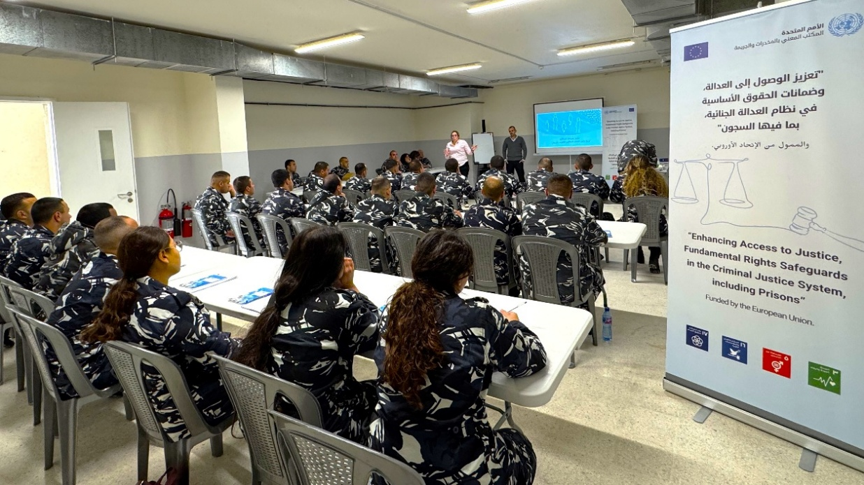

Main achievements
- Upgraded the BASEM prison information system to support juvenile rehabilitation at the Warwar Centre, enabling systematic tracking of education, vocational training and rehabilitation.
- Strengthened data-driven prison management, training 7 Warwar Centre staff on BASEM, improving data accountability, and correcting under-utilization at Saida Prison through administrative follow-up.
- Supported justice sector efficiency through analytics, producing multiple BASEM-based reports that informed the re-opening and institutionalization of the Roumieh Prison Court and accelerated case processing.
- Improved detention conditions and essential services, delivering refurbishments, safety upgrades, connectivity, fuel, and health support across key facilities, including 785 health kits distributed nationwide and 50 bed sheets provided to Tripoli Women’s Prison.
- Built human rights–based capacity for detention staff and partners, delivering specialized training to 34 ISF personnel from juvenile facilities and engaging 11 NGOs and teachers to strengthen coordination and child-centered rehabilitation.
- Expanded rehabilitation and vocational programming, engaging 22 prisoners in vehicle maintenance training (completing 297 repairs) and 30 prisoners in kitchen and bread production training.
Activity 3.1: Actions to support the production of prisoners’ statistics with a view to improve the tracking and analysis of prisons’ population levels and alternative to detention opportunities (i.e., upgrading prisoners’ digital record systems, case file management systems, etc.) in line with data protection standards

- During In 2025, updates to the prison information management system (BASEM) were successfully completed to adapt the system to the operational needs of the Rehabilitation Centre for Children in Conflict with the Law in Warwar. The system was customized to reflect the specific nature of juvenile rehabilitation, including enhanced functionality to monitor children’s participation in educational, vocational training, and rehabilitation programmes. These improvements strengthened individual case management and enabled more systematic tracking of rehabilitation progress. Customized training will occur on the new additions to the system in early 2026.

- To support effective use of the system, a total of 7 personnel from the Rehabilitation Centre for Children in Conflict with the Law were trained on BASEM during 2025. This process included close coordination with the ISF IT Department to ensure that each trained staff member was provided with individual usernames and passwords, thereby promoting accountability, data security, and consistent system usage. In addition to the training, on-the-job support was part of the follow-up to make sure that each person understands their role and duty within the prison information system.

- UNODC also continued to provide technical follow-up and oversight through regular monitoring of data entry within BASEM, ensuring the accuracy, completeness, and timeliness of information recorded in the system. Through this monitoring process, UNODC identified gaps in data entry practices at Saida Prison, where personnel were not consistently updating records in BASEM. After several communications and follow ups with Saida Prison, it became evident that the staff member did not want to work on the system. In response, UNODC coordinated with the ISF prison administration who then took the administrative decision to replace the staff member. While the entry improved, UNODC continues to monitor to ensure proper use of the system. UNODC’s interventions contributed to improved system utilization, strengthened institutional capacity, and enhanced data-driven management across both juvenile and adult detention settings.

- In 2025, UNODC supported the Ministry of Justice (MoJ)/Directorate of Prisons, in the development of a series of data-driven reports using BASEM to inform policy and operational decision-making within the criminal justice system. At the request of the MoJ/Directorate of Prisons, UNODC produced detailed analytical reports on the functioning and impact of the court operating within Roumieh Prison. These reports covered two distinct periods, from June to August 2025, and assessed key indicators related to case processing, court usage, and contribution to the acceleration of criminal proceedings. A follow-up report was subsequently developed to support advocacy efforts for the court’s continued operation.

- The Roumieh Prison Court had been non-operational for several years due to limited engagement by lawyers and judges. In May 2025, recognizing the need to reduce prolonged pretrial detention and expedite criminal justice procedures, the MOJ issued a directive to re-open the court. The court resumed operations in June 2025, and UNODC was subsequently requested to generate evidence demonstrating the court’s effectiveness using BASEM data. Below is an example of one graph derived from one of the reports using BASEM and presented to the MOJ/Directorate of Prisons.
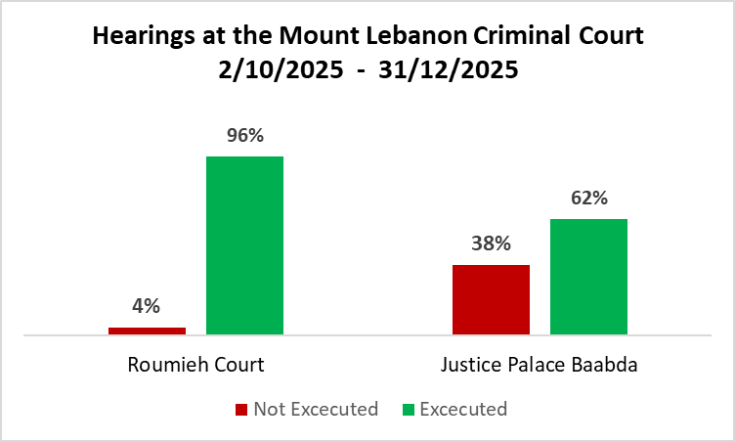

- The graph above covers the period from 2 October to 31 December and shows that, during this timeframe, Roumieh Court conducted a higher number of hearings than the Justice Palace in Baabda while recording fewer non-executed hearings. This reflects greater operational effectiveness, as a larger proportion of scheduled hearings were successfully carried out. The graph forms part of a broader UNODC report assessing efficiency and cost-effectiveness, which highlights the operational advantages of holding court sessions within the prison environment, including reduced detainee transport requirements, enhanced security, and faster case processing.

- All reports were formally submitted by the MoJ/Directorate of Prisons to the Minister of Justice and served as key advocacy tools to support the institutionalization and continued operationalization of the Roumieh Prison Court. This achievement underscores the value of data-driven approaches in strengthening justice sector efficiency, reducing detention-related backlogs, and informing sustainable policy decisions.

- UNODC was further requested to support in the development of an analytical report on the status of Syrian detainees within the Lebanese prison system. Using data extracted from BASEM, the report provided an overview of the total number of Syrian detainees, disaggregated by criminal justice status, including pretrial detainees and sentenced prisoners. At the request of national authorities, UNODC subsequently refined the analysis by further disaggregating the data according to the type of offence, excluding individuals charged or convicted of terrorism or murder-related crimes. This additional level of analysis was undertaken to respond to specific policy and legal considerations raised by the authorities. The request for this report coincided with the emergence of national-level discussions regarding the potential repatriation of Syrian detainees to Syria. By providing accurate, disaggregated, and up-to-date data, the report supported informed dialogue and evidence-based decision-making, ensuring that policy discussions were grounded in reliable information while respecting legal distinctions between categories of detainees.

Activity 3.2: Capacity building activities for judicial and prison staff, human rights-based tailor-made ‘on-the-job” training and mentoring including focus on vulnerable groups (women and children).

- A three-day specialized training programme was conducted for 34 ISF personnel from the Rehabilitation Centre for Children in Conflict with the Law (Warwar) and the Moubadara girls’ facility. On the final day of the training 11 representatives of non-governmental organizations, authorized by the MOJ to work with children in conflict with the law and teachers also participated, strengthening coordination and a shared understanding of roles and responsibilities.

- The first two days of the training focused on building the capacity of ISF personnel to effectively manage juvenile rehabilitation facilities in line with international human rights standards. Sessions covered key operational and security aspects, including communication with children, reception and admission procedures, conducting counts and searches, discipline and behavior management, and facility security, all framed within a child-sensitive and rights-based approach. This was particularly important as the ISF do not receive any formal corrections training; therefore, many prison staff are inserted into the system without any guidance or training and learn on the job through more experienced staff. This training provided them with some guidance as well as practical exercises to ensure they are able to conduct their responsibilities effectively.

- In addition to the formal training sessions, on-the-job training was provided to support facility staff in the implementation of key operational procedures. This included guidance on medical referral processes to ensure examinations by ISF medical doctors, preparation of incident reports, and processing of official support requests to ISF headquarters. Hands-on training on search procedures was also delivered. These practical interventions strengthened operational readiness and reinforced the consistent application of standard procedures in daily practice.

Activity 3.3: Capacity building activities for prison staff and NGOs on human rights-based approach to improve rehabilitation programmes with a particular attention on high-risk profiles, prevention of radicalization and violent extremism along with the development/upgrade of tools addressing disengagement from violence

- The third day brought together ISF personnel and NGO partners to strengthen inter-agency collaboration. Sessions included an overview of the role and mandate of the Ministry of Justice Juvenile Department, delivered by its Head, and a dedicated session on the application of Law No. 422, led by a juvenile judge. Additional modules addressed risk and protective factors for children in conflict with the law, introduced the facility’s structure and rehabilitation programming (presented by the ISF social worker), and provided practical conflict-resolution tools. These discussions enhanced participants’ understanding of the drivers of juvenile offending, the applicable legal framework, and the central role of rehabilitation within the facility.

- The training adopted a participatory methodology, combining theoretical inputs with practical exercises, group work, and scenario-based discussions. The joint group sessions involving both ISF personnel and NGO representatives were particularly valuable in fostering collaboration, coordination, and a shared child-centred approach to rehabilitation.

Activity 3.4: Small-scale refurbishments to enhance detention conditions and provision of services to cover basic needs of prisoners with particular attention to the needs of female and children in prison

- To strengthen safe and dignified detention conditions across Lebanon, UNODC provided comprehensive maintenance, refurbishment, and essential support, resulting in tangible improvements in safety, hygiene, and operational efficiency. At Roumieh Prison, projectors, sensors, and circuit breakers were installed to illuminate the main road from the facility entrance to the cell blocks, enhancing visibility and overall security for staff and detainees. Pesticides were procured and applied to eliminate pests, further safeguarding health conditions, and diesel fuel was supplied to maintain uninterrupted power for the facility’s generator. Additionally, an internet link between Roumieh Prison and ISF Headquarters was established, supporting the continuous operation of BASEM and maintaining connectivity with headquarters.

- At the Moubadara facility for girls in conflict with the law, targeted refurbishment work, including electrical installations, painting, and plumbing, improved living conditions and the overall environment for detainees. Complementing these infrastructure upgrades, UNODC distributed approximately 785 health kits to detention centres nationwide and 50 bed sheets to Tripoli Women’s Prison, reinforcing basic sanitation standards and promoting detainees’ health and well-being. Collectively, these interventions have enhanced the safety, hygiene, and dignity of detention facilities while supporting the operational efficiency and sustainability of facility management.

Activity 3.5: Establish and equip a pilot recycling workshop in Roumieh prison to promote awareness among prisoners, staff, and families with the aim to support the provision of in-kind contributions from NGOs and plastic industry (hygiene products and health kits) in return of the plastic collected.

- Due to persistent staffing shortages, this activity could not be implemented as originally planned and was therefore removed through the project addendum under the no-cost extension. Nevertheless, UNODC proactively explored alternative options by engaging with a well-established non-profit organization that has led recycling initiatives in Lebanon for over a decade. Consultations with the organization revealed significant feasibility challenges that would limit the viability and sustainability of a recycling intervention at Roumieh Prison. The non-profit clarified that it does not provide in-kind contributions and noted that potential revenue generated from recycling activities within the prison would be minimal. Additionally, the costs associated with transporting recyclable materials to secondary sorting sites were assessed as high, unless transportation were undertaken by the ISF. This, however, presented further constraints due to limited staffing capacity and an insufficient number of transport vehicles and drivers.

- The assessment further highlighted that for a recycling operation to be economically and operationally viable, it would require a very high volume of waste, extending beyond Roumieh Prison to include surrounding areas. Implementing such an approach would necessitate the establishment of formal procedures governing the entry and exit of recyclable materials from the facility, an inherently complex process requiring extensive coordination and further discussion with the ISF. Moreover, scaling up the activity would demand additional space within the facility and increased staffing levels, which are currently unavailable. Collectively, these operational, logistical, and administrative constraints constituted significant barriers to implementation, ultimately rendering the activity unfeasible within the project’s timeline.

- Despite these limitations, UNODC capitalized on the engagement by receiving training from the non-profit organization on recycling principles and best practices. Building on this knowledge, UNODC plans to conduct a targeted awareness-raising activity with children in conflict with the law at the rehabilitation center, with the aim of promoting environmentally responsible behavior both during their stay at the facility and following their release. This approach ensures that, while large-scale operational recycling was not feasible, the project continues to contribute to longer-term behavioral change and environmental awareness among beneficiaries.

Activity 3.6: Enhance the car repair and maintenance workshop for ISF escort vehicles to ensure sustained transfer of prisoners to Courts

- At Roumieh Prison, the vehicle maintenance programme continued to operate, engaging 22 prisoners in vocational training vehicle repair workshop. Throughout 2025, a total of 297 repairs were completed, including 196 oil changes, 39 brake replacements, and 62 mechanical and aesthetic repairs. A final procurement of essential materials is planned for early 2026 to sustain the programme.

- This initiative is important because it provides prisoners with practical vocational skills that can enhance their employability upon release, promoting rehabilitation and social reintegration. In addition, the programme fosters a sense of purpose and responsibility among participants and contributes to the overall maintenance and functionality of institutional assets. By combining skills development with operational support, the programme strengthens both individual capacities and institutional resilience.

Activity 3.7: Improve the capacity of prison staff and prisoners to ensure food safety in the central kitchen as well as supporting bread production.

- In 2025, approximately 30 prisoners participated in the vocational training kitchen and bread workshops at Roumieh prison. To ensure the continuity of safe and reliable food preparation at Roumieh Prison, UNODC replaced essential kitchen equipment, including gas stoves, thereby strengthening the functionality of the central kitchen and supporting daily meal provision. In parallel, UNODC provided targeted support to the staff cafeteria through the procurement of food items and essential equipment, enabling the provision of at least one daily meal to staff working extended shifts. This intervention contributed to staff well-being and operational endurance, particularly given the demanding working conditions within the facility.

- This support included the procurement of diesel to ensure uninterrupted operations, as well as the provision of essential raw materials required for bread production. In an effort to promote sustainability, UNODC explored options for transferring management of the bread oven to the ISF; however, the ISF indicated that it lacked the financial resources and staffing capacity necessary to sustain operations. As an alternative, UNODC engaged with the ISF Social Services Unit, which benefits from an independent funding source and employs qualified bakers and cooks.

- Discussions subsequently focused on expanding the bread oven’s capacity and operating hours to increase production and generate revenue through bread sales, thereby supporting financial sustainability. While initial interest was expressed and UNODC offered transitional support, a subsequent review of operational costs and an internal feasibility assessment led the unit to conclude that the initiative would not be cost-effective under prevailing conditions. Consequently, despite sustained efforts to identify a viable operational model, the bread oven was ultimately discontinued

Activity 3.8: Develop programmes and cooperation in collaboration with central/local authorities and CSOs aiming reintegration of prisoners, with particular attention to the needs of females (i.e., expanding the offer of education, vocational training, income generating activities and life skills schemes).

- Within Roumieh prison, crime prevention activities through sports continued in the first half of 2025 with approximately 30 prisoners charged with terrorism-related offenses and violent extremism engaging in sports activities. The importance of this was not just to promote physical health, and teamwork but also to promote tolerance especially since the facilitator came from a different socio-religious background.

- Due to sustainability challenges, further programmes could not be maintained. Rehabilitation and reintegration programmes within detention facilities are not yet institutionalized and remain largely dependent on Non-Governmental Organizations and United Nations agencies, making them highly reliant on time-bound donor funding. This reliance limits the ability to ensure continuity beyond project cycles. These challenges are further compounded by structural constraints within the Internal Security Forces (ISF), including limited financial and human resources, insufficient staffing levels, and restricted physical space in certain facilities, which together constrain the consistent delivery of programming.

- In light of these limitations, UNODC has decided to refocus the activity toward more feasible and impactful interventions. Beginning in 2026, the emphasis will shift to life skills development for prisoners, with the objective of strengthening individual capacities, supporting successful reintegration, and maximizing impact within existing operational constraints. These interventions will be implemented in close coordination with non-governmental organizations capable of providing post-release support, ensuring continuity of assistance beyond detention. This strategic adjustment reflects a pragmatic and sustainability-oriented approach, allowing UNODC to continue advancing rehabilitation objectives in alignment with available resources and institutional capacities.

Output 4
Detention conditions, education/social programmes and services for children in conflict with the law are improved, including the operationalization of the Warwar correctional facility for children (boys), with particular attention to the specific needs of girls
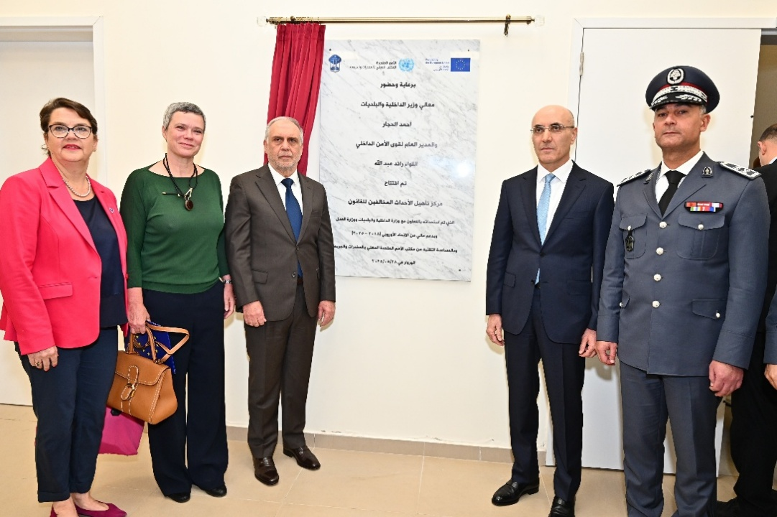

Main achievements
- Completed all engineering works and fully equipped the Warwar Rehabilitation Centre, with formal handover to the ISF, enabling the permanent separation of children from adult detainees in line with international standards.
- Equipped classrooms, workshops, family visit areas, dining hall, kitchen, and IT rooms with essential furniture, computers, vocational equipment, fire safety systems, and family communication tools, creating a safe and child-friendly rehabilitative environment.
- Engaged 150 boys in vocational, educational, sports, and PVE-focused activities, with structured classes of 15 participants and twice-weekly sports sessions for all residents at the Warwar facility.
- Achieved 100% participation (18 girls) at Moubadara in weekly vocational training and life-skills programmes, complemented by psychosocial and recreational activities supporting well-being and reintegration.
- Installed the Tabshoura e-learning platform at two facilities, launched twice-weekly classes for boys, enabled phone and video communication with families, and supported CSO-led vocational activities, with further expansion planned for 2026.

Activity 4.1: Provision of supplementary engineering services, equipment, and furniture to the new Warwar correctional centre to support a rehabilitative, safe and child friendly environment (room, library, workshops, family visit areas etc.) for children

- By March, UNODC successfully finalized all engineering services and completed the procurement and installation of essential equipment and furniture for the Rehabilitation Centre for Children in Conflict with the Law, ensuring the facility was fully operational and fit for purpose. Key infrastructure improvements included the installation of a comprehensive electrical system, a water filtration and pressure pump system to guarantee continuous access to clean water, and the connection of telephone lines throughout the facility. This included the installation of “telecarte” phones in each residential wing, enabling children to maintain regular contact with their families and strengthening family ties as part of the rehabilitation process.

- To support dignified visitation and learning environments, benches and tables were procured for the visitation room and waiting areas, while classrooms were equipped with computers and IT equipment, including PCs and uninterrupted power supplies, enabling literacy, computer, and educational programming such as the tabshoura classes. Workshops were furnished with cabinets and essential equipment, including welding machines, supporting the delivery of vocational and skills-based activities. Operational capacity was further strengthened through the provision of office furniture, stationery, safes, and storage drawers for ISF personnel offices and meeting rooms, ensuring secure information management and effective administration.

- Additional tables, chairs, and garbage bins were supplied to the dining hall, while the main kitchen was fully equipped with refrigerators, a freezer, and cooking utensils, enabling safe and efficient food preparation. A fire system was installed throughout the facility, to ensure the early detection of fire and smoke allowing early evacuation. In addition, the videocall room was set up to allow children to communicate with their families, further strengthening family bonds.

- Following the near completion of all works, a joint walkthrough and technical assessment was conducted in with the ISF building committee to verify readiness for handover. After approval and the resolution of minor snags, the facility was formally handed over to the ISF. The centre was officially inaugurated in May 2025 during a high-level event jointly led by the MoIM, the ISF, the MOJ, the EU Delegation to Lebanon, and UNODC.

- The establishment of this rehabilitation centre marks a significant milestone in aligning Lebanon’s juvenile justice system with international standards, norms, and best practices. The facility provides a child-sensitive, and rehabilitative environment for boys who were previously held in the juvenile wing of Roumieh Prison, ensuring the permanent separation of children from adult detainees. By transferring children to a purpose-built setting, the initiative aims to mitigate the harmful effects of incarceration and creates conditions conducive to rehabilitation, well-being, and successful reintegration into society.

Activity 4.2: Implementation of rehabilitation programmes aiming at the rehabilitation and social reintegration of children in conflict with the law, paying specific attention to the needs of girls

- Girls at the Moubadara facility participated in four weekly life-skills and vocational training sessions, including one weekly session in hairdressing, one in cooking, and two weekly sessions in needlework (knitting and crocheting). Life-skills programming further included fortnightly film and discussion sessions and monthly thematic workshops on personal development topics such as hygiene, drugs, juvenile law, and stress management. A total of 18 girls participated in these activities, representing 100% of the population at Moubadara.

- For boys at Roumieh, 150 children participated in rehabilitation activities, including three weekly sessions each in mechanical, electrical, and computer skills training. This was complemented by two weekly sessions of Line Up Live Up (LULU), a sport-based crime-prevention programme, and the Preventing Violent Extremism among Children and Young Adults in Detention and Strengthening Resilience toolkit, reaching 40 boys. Following relocation to the Warwar facility, programming continued with three weekly sessions each in electrical and computer skills training, with 15 boys per class. In addition, all boys at the facility participate in two weekly sports sessions and supplementary recreational activities, including board games and arts.

- To commemorate Lebanese Independence Day, UNODC, at the request of the Colonel overseeing the facility, supported and participated in a celebratory event for children in detention. UNODC contributed to organizing the event, including the provision of a celebratory cake, and facilitated a group activity in which four children, supported by UNODC staff, prepared sandwiches for all residents, promoting cooperation, inclusion, and positive peer interaction.

- In December, UNODC implemented a Christmas-themed activity aimed at promoting tolerance, social cohesion, and disengagement from violence among juveniles in detention. Through facilitated discussions, children reflected on the meaning of Christmas and gift-giving, fostering empathy, generosity, and peaceful coexistence. On 27 December, these objectives were further reinforced through interactive games and music-based activities that provided a safe space for self-expression, positive social interaction, and emotional release.

- These activities enabled juveniles to engage freely through play and dance, contributing to improved well-being, trust-building, and constructive engagement within the facility. For girls participating in the Moubadara programme, UNODC additionally organized a group lunch accompanied by cake and recreational activities, including a game of Charades, creating a supportive environment that fostered trust, positive engagement, and psychosocial well-being.

- In late 2025, UNODC piloted a chess class in collaboration with the Lebanese Chess Federation as a structured educational and recreational intervention to strengthen critical thinking, patience, and non-violent problem-solving skills. Based on positive initial engagement, the activity is scheduled for full implementation in 2026.

- UNODC also installed the Tabshoura e-learning platform, aligned with the Lebanese national curriculum in Arabic, English, and French, at both Moubadara and the new boys’ centre. Twice-weekly Tabshoura classes have commenced at the boys’ facility, delivered by the NGO Afif Assayran, whose staff received training from UNODC. At Moubadara, classes are scheduled to begin in 2026.

Activity 4.3: Support activities with CSOs and local authorities aiming at the reintegration of children in the communities as well as preventing violent extremism.

- Additional furnishings and equipment were provided to the Rehabilitation Centre for Children in Conflict with the Law – Warwar to support CSO-led rehabilitation activities. Classroom tables enabled the implementation of a solar panel repair workshop by Irshad wa Islah, while kitchen equipment was supplied in preparation for cooking classes to be delivered by Foundation Père Afif Ousseiran in 2026. These interventions built on prior coordination between UNODC and partner CSOs to finalize the rehabilitation curriculum in 2024.

- Final considerations on risks and way forward

- Advancing judicial reform will remain a central priority in the period ahead, particularly as engagement deepens with newly appointed authorities and reform windows narrow. The Justice Forum has demonstrated its value as a credible platform for structured, technically grounded dialogue, notably through the completion of the thematic group on the Independence, Accountability and Professionalism of the Judiciary and its tangible contribution to legislative reform. Going forward, emphasis should shift from convening to consolidation—ensuring that thematic outputs are finalized, sequenced, and translated into implementable measures, while maintaining a balance between inclusivity and efficiency and mitigating risks linked to uneven participation and limited institutional availability.

- The conclusion of the first thematic group and the subsequent adoption of the Law Organizing the Judiciary No. 36/2026 marked important, if partial, advances in a reform area long constrained by political dynamics. While the law represents progress compared to the previous framework, stakeholder feedback highlights persistent gaps in guarantees for judicial independence and accountability. As such, the focus in the coming period should be on supporting implementation, sustaining policy dialogue, and leveraging the nearing completion of the thematic roadmap to address outstanding shortcomings through complementary reforms, advocacy, and technical engagement—without overstating the Forum’s role as a substitute for formal legislative and constitutional processes.

- Other Justice Forum tracks have advanced at different paces, underscoring the importance of adaptive sequencing. The Efficiency, Transparency, Digitalization, and Accessibility thematic group is nearing completion, while the Criminal Justice and Human Rights group will continue into 2026, reflecting the technical complexity of the issues addressed and the need for sustained engagement with both judicial and security actors. Preparatory work for the Juvenile Justice thematic group is complete, but its delayed launch highlights the continued vulnerability of reform processes to institutional disruptions. Going forward, careful prioritization and realistic timelines will be essential to ensure coherence across thematic outputs and prevent reform fatigue.

- In parallel, progress in detention reform—most notably the establishment of the Rehabilitation Centre for Children in Conflict with the Law in Warwar—demonstrates the project’s capacity to deliver concrete, rights-based improvements even in constrained environments. However, chronic staffing shortages within the ISF, high turnover, insufficient training, and weak infrastructure maintenance continue to pose significant risks to sustainability. Without systematic investment in human resources, operational capacity, and basic infrastructure, gains in detention conditions and rehabilitation risk remaining fragile and uneven.

- The way forward should therefore prioritize consolidation over expansion. Continued targeted training for ISF prison staff, strengthened use and monitoring of the BASEM system, and focused operational and infrastructure support under the no-cost extension will be critical. At the same time, rehabilitation, education, and vocational programmes should be progressively anchored within national systems, notably through closer coordination with the Ministry of Social Affairs, to reduce long-term dependence on external actors. Where feasible, vocational initiatives that contribute to internal maintenance capacity should be pursued, provided sustainability and feasibility can be reasonably ensured.

- As the project enters its final year, early planning for a complementary next phase of support is essential to avoid funding gaps and loss of momentum. While the Justice Forum has already contributed to meaningful reform outcomes, including legislative change, several reform tracks remain incomplete or insufficiently institutionalized. Future programming should therefore build on existing achievements, support the implementation of adopted reforms, and complete outstanding thematic work—particularly in criminal justice, human rights, and juvenile justice—while remaining responsive to institutional capacity constraints and political realities.

V. Results Framework
EXPECTED OUTPUTS | OUTPUT INDICATORS | BASELINE |  | Overall TARGETS | ACTUAL  2025 | Cumulative
EXPECTED OUTPUTS | OUTPUT INDICATORS | Value | Year | Value | ACTUAL  2025 | Cumulative
Output 1  Access to justice to vulnerable groups is enhanced with a focus on the criminal justice chain and mediation mechanism | 1.1 # persons benefitting from services from new legal aid helpdesk (disaggregated by gender, type of services) | 0  Desk not yet established | 2022 | 4000 | 1362 (731)  - Awareness & information: 1246 (654)  - Counselling: 40 (24)  - Representation: 20 (11)  - Assistance: 45 (33)  - Mediation 11 (9) | 3027 (1688)  - Awareness & information: 2730 (1499)  - Counselling: 121 (74)  - Representation: 72 (42)  - Assistance: 91 (62)  - Legal information: 2  - Mediation 11 (9)
 | 1.2 # Detention centers having a functional legal aid helpdesk | 0 | 2022 | 2 | 2 | 2
 | 1.3 % of detainees from supported detention centers benefitting from services of the legal aid helpdesk | 0  no desk established | 2022 | 15% | Roumieh Prison: 16.2 %  Baabda Prison: 66.3 % | Roumieh Prison: 13.7 %  Baabda Prison: 67.3 %  Sum of beneficiaries/sum of targeted prison wings
 | 1.4 # individuals benefitting from legal assistance during investigation phases supported through Bar associations referral mechanisms | Tripoli Bar: 60  Beirut Bar:  TBD | 2022 | 300 | Tripoli: 80  Beirut: 144 | Tripoli: 260  Beirut: 244
 | 1.5 # justice/security actors sensitized and/or trained on art 47 guarantees (disaggregated by category of actors and gender) |  |  | 100 | 871, including 534 women  - 8 ISF personnel  - 471 Lawyers and lawyers in training  - 21 GSO personnel  - 30 LAF personnel  - 46 State security personnel  - 101 University students  - 194 Civil society actors | 2200, including 1481 women  - 146 ISF personnel  - 1277 Lawyers and lawyers in training  - 1 Judge  - 46 State security personnel  - 21 GSO personnel  - 30 LAF personnel  - 191 University students  - 488 Civil society actors
 | 1.6 # awareness sessions on mediation/ADR conducted | n/a |  | 15 | n/a | 23
 | 1.7 # pilot police stations fully implementing art. 47 guarantees | 0 | 2022 | 3 | 0 | 0
Output 2  Effectiveness and independence of justice oversight institutions and mechanisms are strengthened | 2.1 # critical justice infrastructures equipped with alternative energy sources | 0 | 2022 | 1 | 1  (Beirut Justice Palace) | 1  (Beirut Justice Palace)
 | 2.2 Progress on developing and implementing methodology for monitoring and inspecting the functioning of the courts | In situ inspections stopped | 2022 | Methodology finalized and at least 5 courts inspected based on the criteria set forth by it | Law passed regarding implementing entity, appointing the judicial inspection authority.  0 courts inspected. | Referentiel d’inspection developed and approved by the High Judicial Council.  Law passed regarding implementing entity, appointing the judicial inspection authority.  0 courts inspected.
 | 2.3 Progress on developing monitoring & oversight tools, and functional/organisational frameworks of justice oversight bodies | 1: judges evaluation criteria developed but, not implemented | 2022 | At least 2 new tools being used/implemented | High Judicial Council database competed and installed  Internal regulation finalized pending approval | High Judicial Council database competed and installed  Internal regulation finalized pending approval
 | 2.4 Progress in strengthening capacities of National Human Rights Commission in light of Paris principles | NHRC is hardly operational | 2022 | NHRC in a position to submit accreditation application to GANHRI | - NHRC bylaws signed by MOJ  - Office premises secured  - Facilitated the release of 85 unlawfully detained prisoners | - NHRC published its annual report 2022.  - NHRC now has access to a budget  - NHRC published its second annual report for 2023.  - NHRC comprehensive assessment on human rights violations in 2024 completed  - NHRC bylaws signed by MOJ  - Office premises secured  - Facilitated the release of 85 unlawfully detained prisoners
Output 3  Prison environment, health conditions and sustainable needs responses are enhanced as per Mandela rules | 3.1 # of areas improved in prisons and detention facilities | 3 | 2021 | 6 prisons and detention facilities improved | 2 prisons | 7 prisons
 | 3.2 # of prisoners (m/f) benefiting from basic services | 1200 benefiting from basic services | 2021 | 2,500 prisoners will have access to better basic services | 835 prisoners including 50 women | 8,654 prisoners, including 6,379 women & 450 children
 | 3.3 # of staff trained on data entry and production of analytical reports | 35 | 2021 | 80 staff trained | 7 staff trained | 73 staff trained
 | 3.4 # of trained staff handling of vulnerable groups (women and children) and high-risk profiles | 10 | 2021 | 70 Staff | 46  ISF (36), CSOs (7), Ministry of Education (3)  Shared activity with 4.2 | 56
 | 3.5 Percentage of prisoners benefiting from rehabilitation and reintegration programmes | 16% | 2021 | 40% prisoners will benefit from rehabilitation and rehabilitation programmes | 1% prisoners benefitting from rehabilitation and rehabilitation programmes | 26% prisoners benefitting from rehabilitation and rehabilitation programmes
 | 3.6 # of pilot recycling workshop | 0 | 2021 | 1 established and equipped workshop | 0 | 0
 | 3.7 # of vocational training and income generating activities improved | 2 | 2021 | 4 improved workshops (vocational training and income generating activities) | 0 improved workshops | 4 improved workshops
Output 4  Detention conditions, education/social programmes and services for children in conflict with the law are improved, including the operationalization of the Warwar correctional facility for children (boys), with particular attention to the specific needs of girls | 4.1 # of additional refurbishments and equipment procured and fully operational | 0 | 2021 | 8 (engineering services, Family visit area, rooms, workshops, library, fire system, drinking water system, etc..) | 9 | 13
 | 4.2 # of staff trained on responding to children’s needs and disengagement from violence | 10 staff trained | 2021 | 35 prison staff, social workers and teachers trained on responding to children’s needs and disengagement from violence | 46  ISF (36), CSOs (7), Ministry of Education (3) | 56
 | 4.3 Percentage of children benefiting from rehabilitation and reintegration programmes | 0% | 2021 | 100% of children will benefit of rehabilitation and reintegration programmes | 100% | 100%

Annex A – Financial Report
Action: Enhancing access to justice, fundamental rights safeguards in the criminal justice system, and independent justice oversight mechanisms
Agreement #: NDICI-GEO-NEAR/2022/ 438-566
Financial report period: 01.01.2025 to 31.12.2025

Note: The above report is provisional to show budget status. Official financial reports will be generated from UNDP Financial System and submitted per agreement

